**Policies and Permissions**

**Step 3.18.1:** Creating a bucket

* Create a new bucket in which we want to add policy with all default settings.

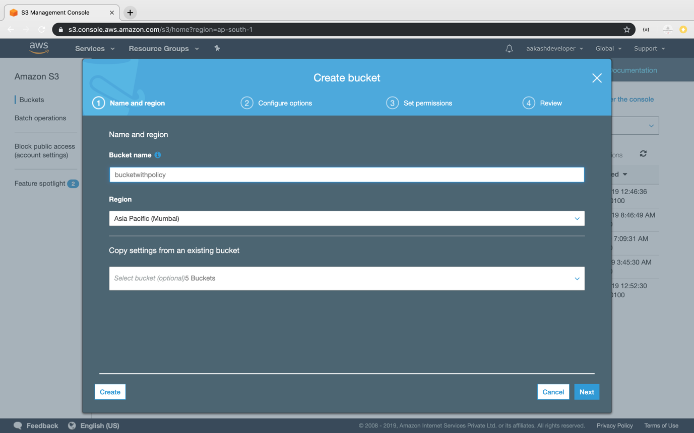

* Click on the *Permission* section.
* Go to *Bucket Policy*.
* It will open the console where you can add policy.

**Step 3.18.2:** Adding policies

* Click on the *Policy Generator*.

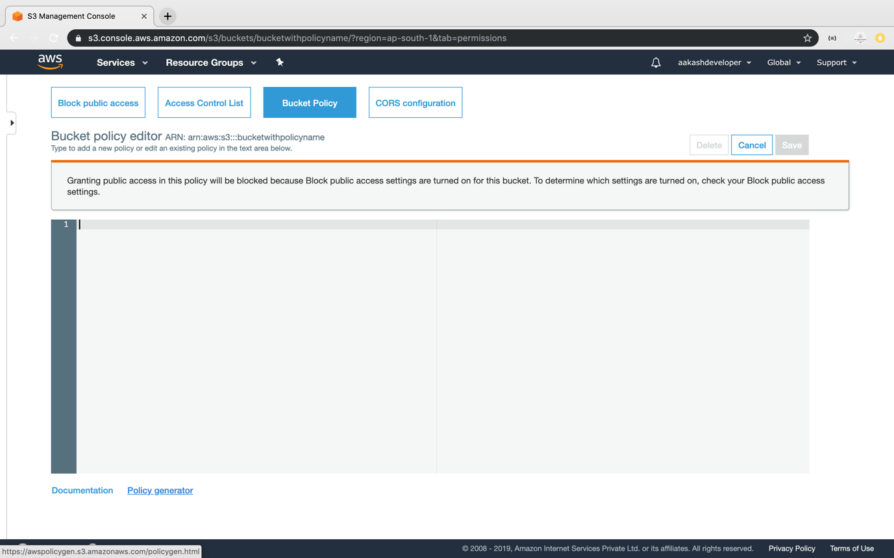

* Select the type of policy and services required.

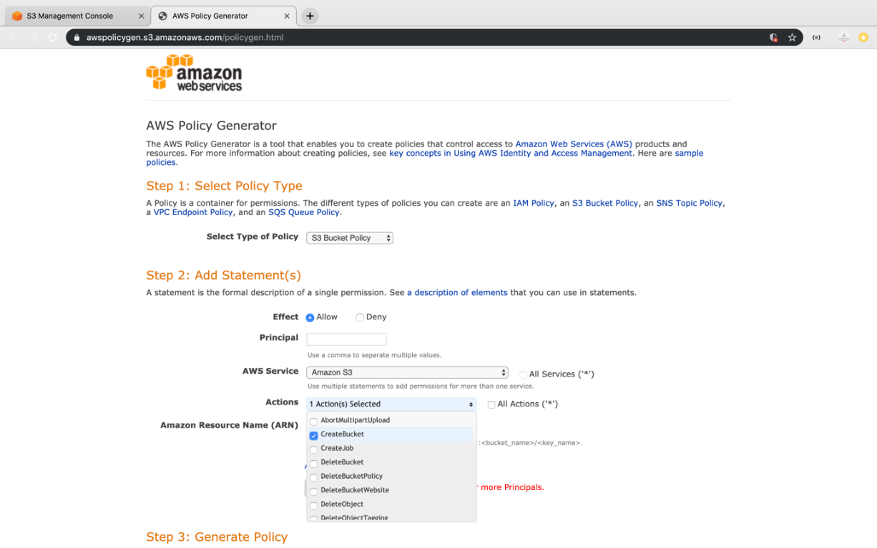

* Add ARN for S3 to add the policy.

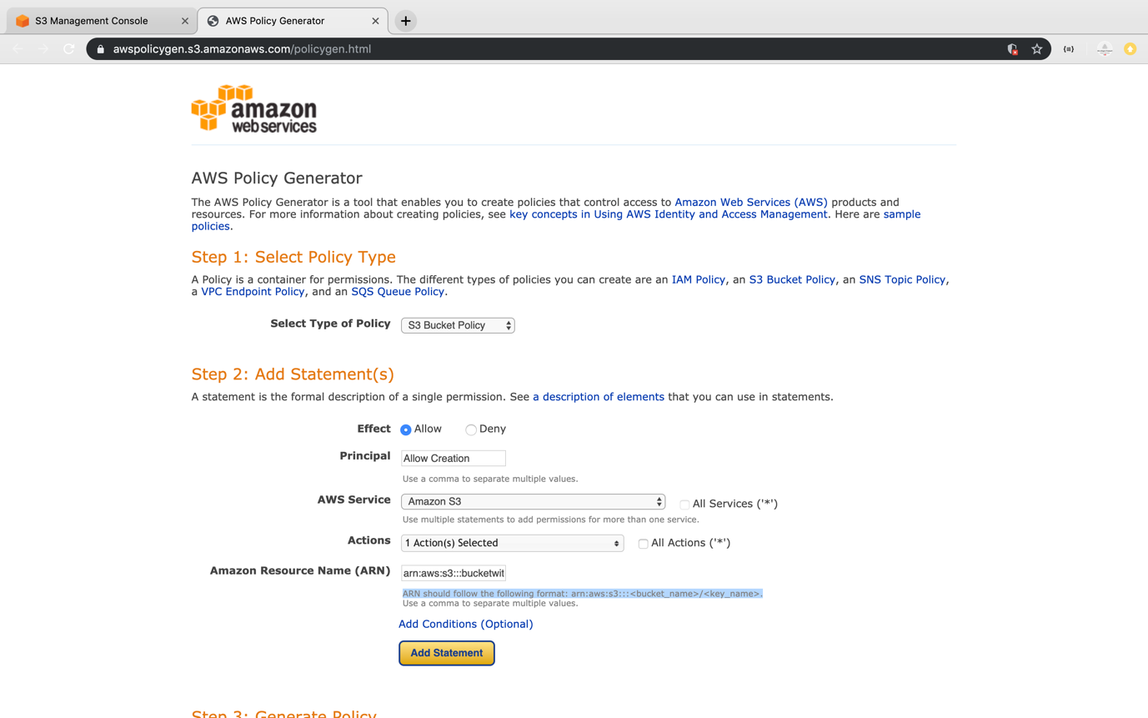

* Click on policy generator to create the JSON of the policy.

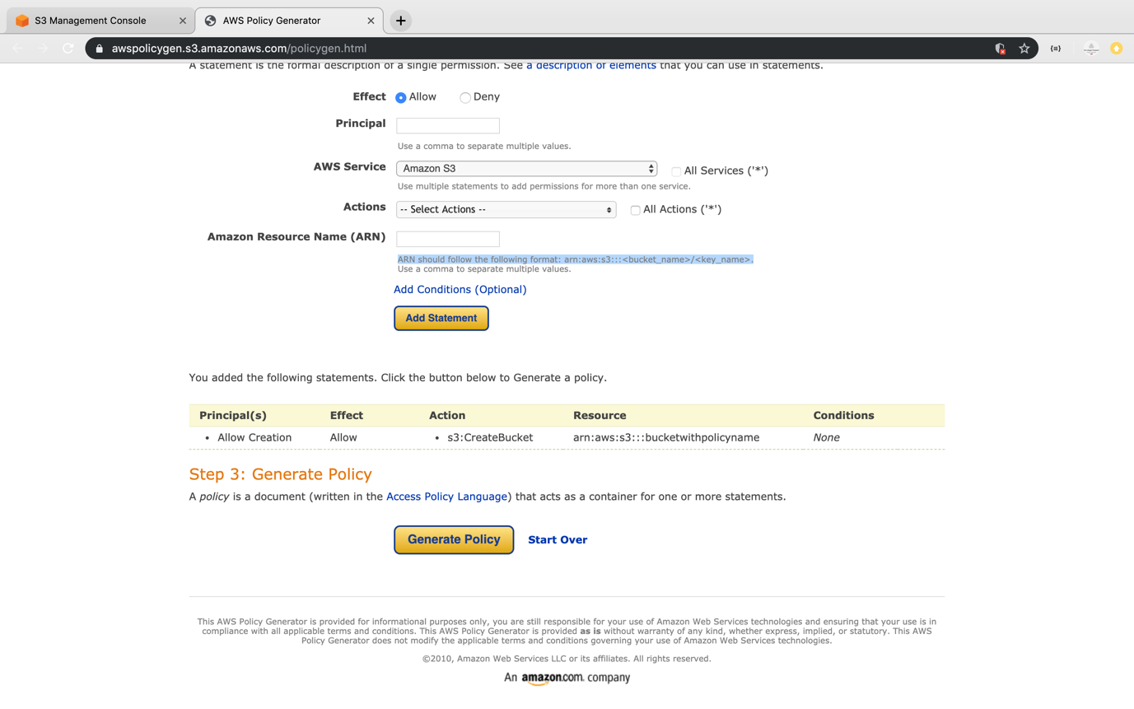

* Copy the generated JSON.

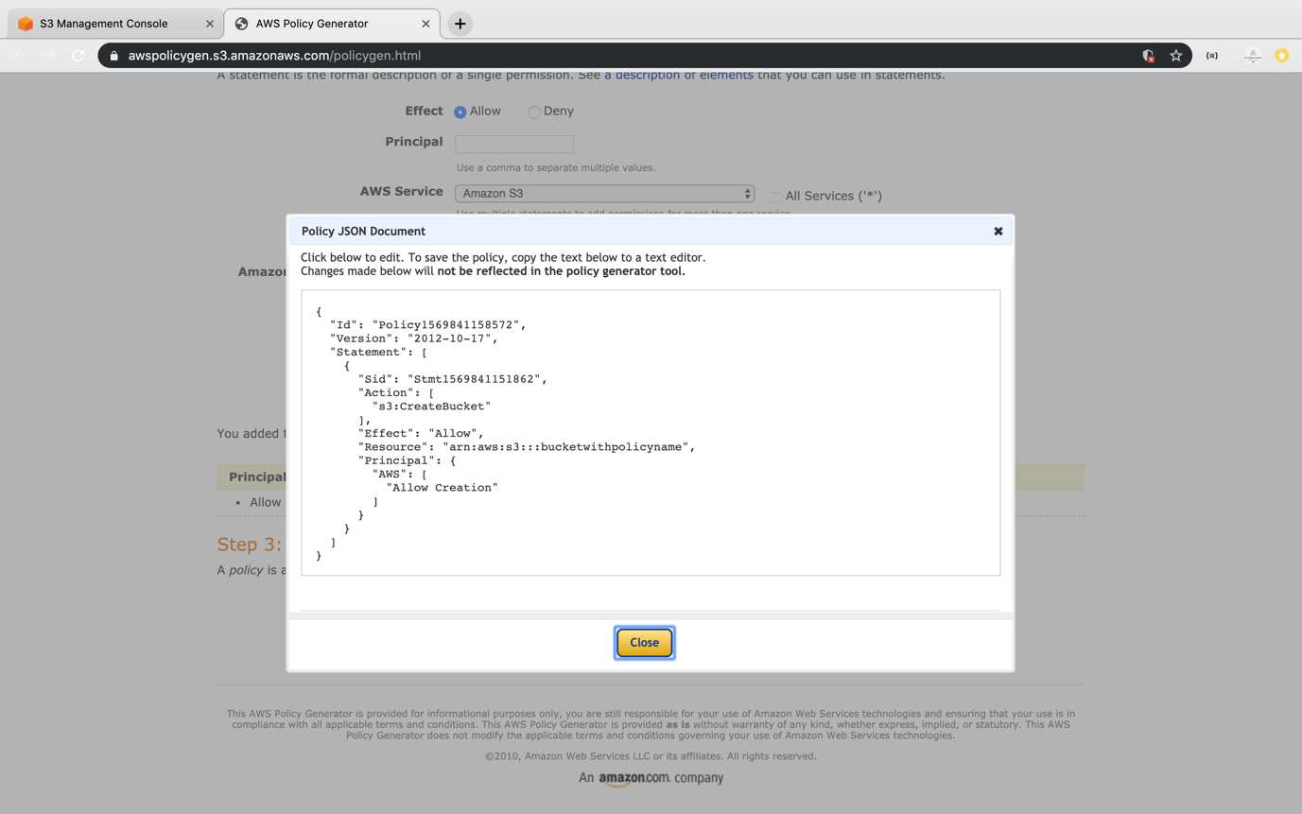

* Paste the JSON in the policy console of bucket and click on *Save*.

